Exercise 4: Creating and Configuring a Maven Project
Scenario:
You need to set up a new Maven project for the library management application and add Spring dependencies.
1. Create a New Maven Project:
o Create a new Maven project named LibraryManagement_Maven.
2. Add Spring Dependencies in pom.xml:
o Include dependencies for Spring Context, Spring AOP, and Spring WebMVC.
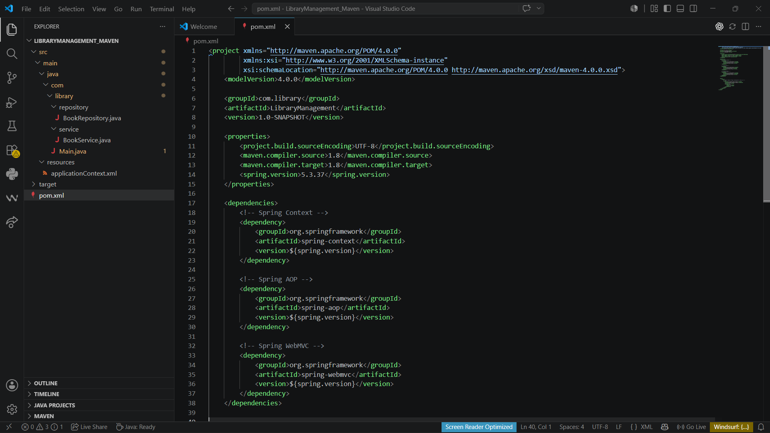

3. Configure Maven Plugins:
o Configure the Maven Compiler Plugin for Java version 1.8 in the pom.xml file.
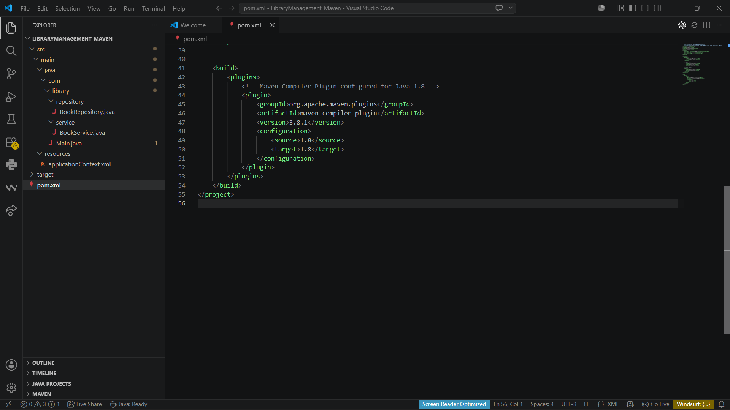
Output:
